**FAYETTEVILLE STATE UNIVERSITY CAMPUS**

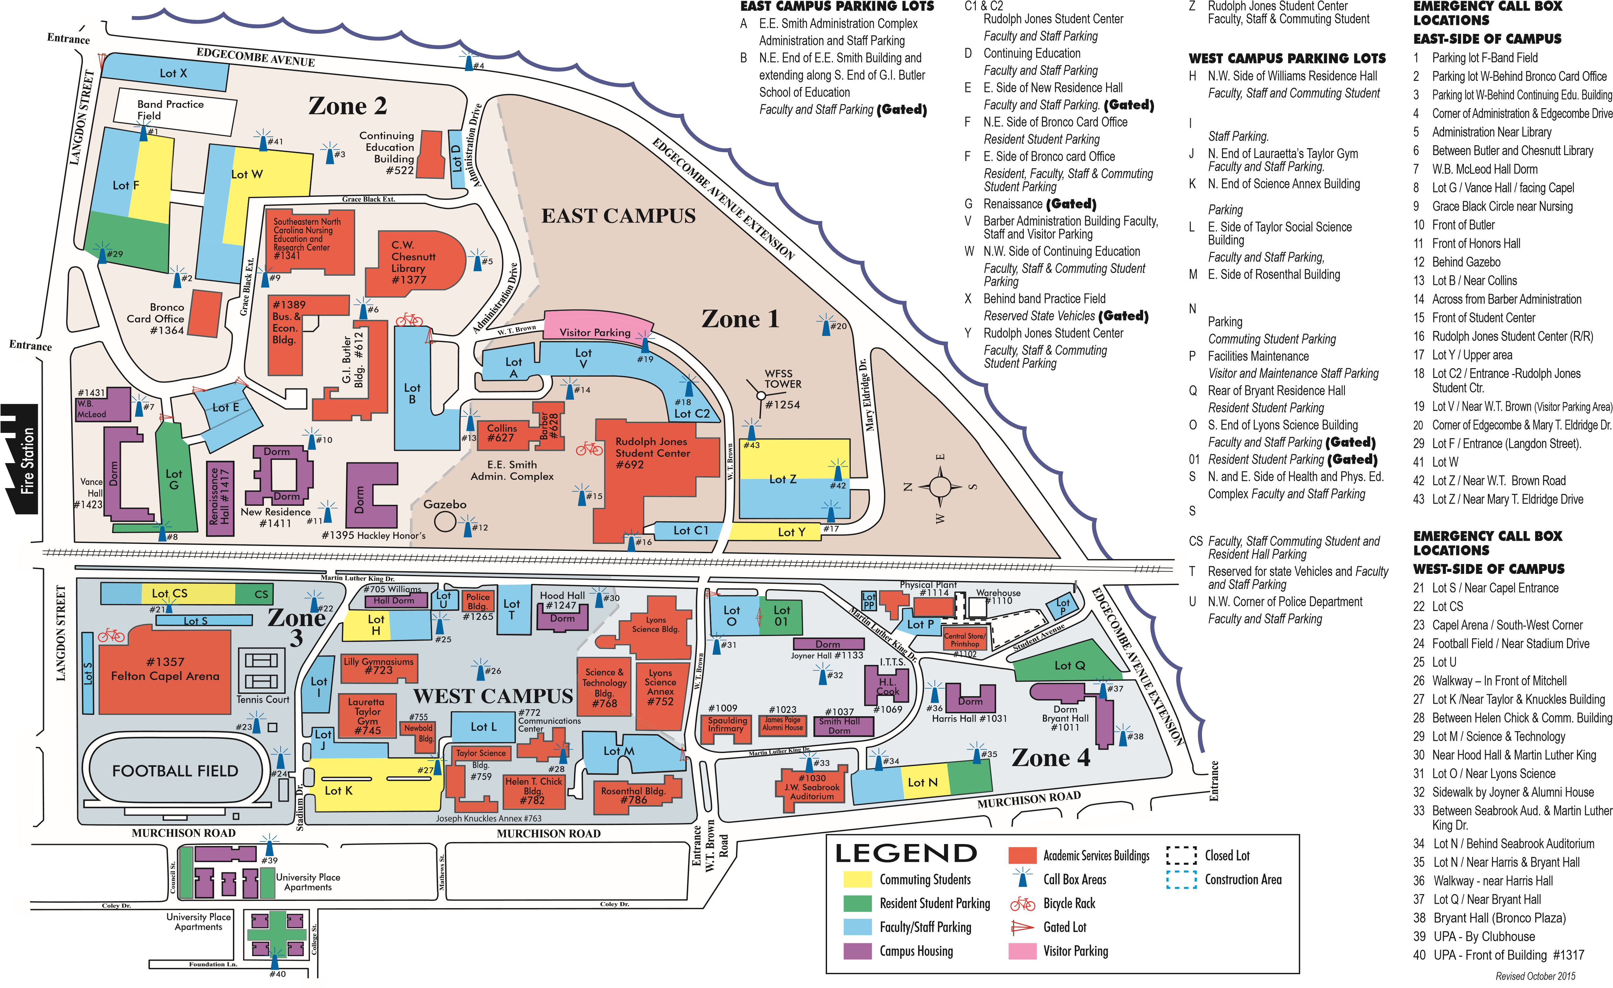

Graduation Parking

Grace Black Circle Parking Lot - Graduates

Lot S – Platform Party and Special Guest Parking

Lot CS – Handicap Parking

All other lots are opened to Guests, Faculty and Staff .

**DO NOT PARK ON SIDEWALKS**